**Name** :**Mohamed Mahmoud Hassan**

**B.N : 790**

**Group:6**

**Sec: 36**

**GitHub link** :

**GitHub page**

**Application Brief:**

Programming language is important because it defines the relationship, semantics and grammar which allows the programmers to effectively communicate with the machines that they program.

A programming language serves several purposes:

1. You can instruct the computer what to do in a human-readable form
2. Allows the programmer to structure the instructions into functions, procedures.

**Project Screenshots:**

**Index:**

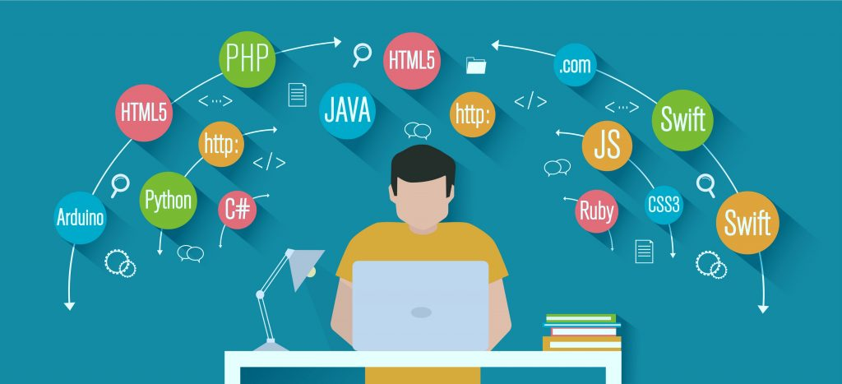

**Language programming page :**

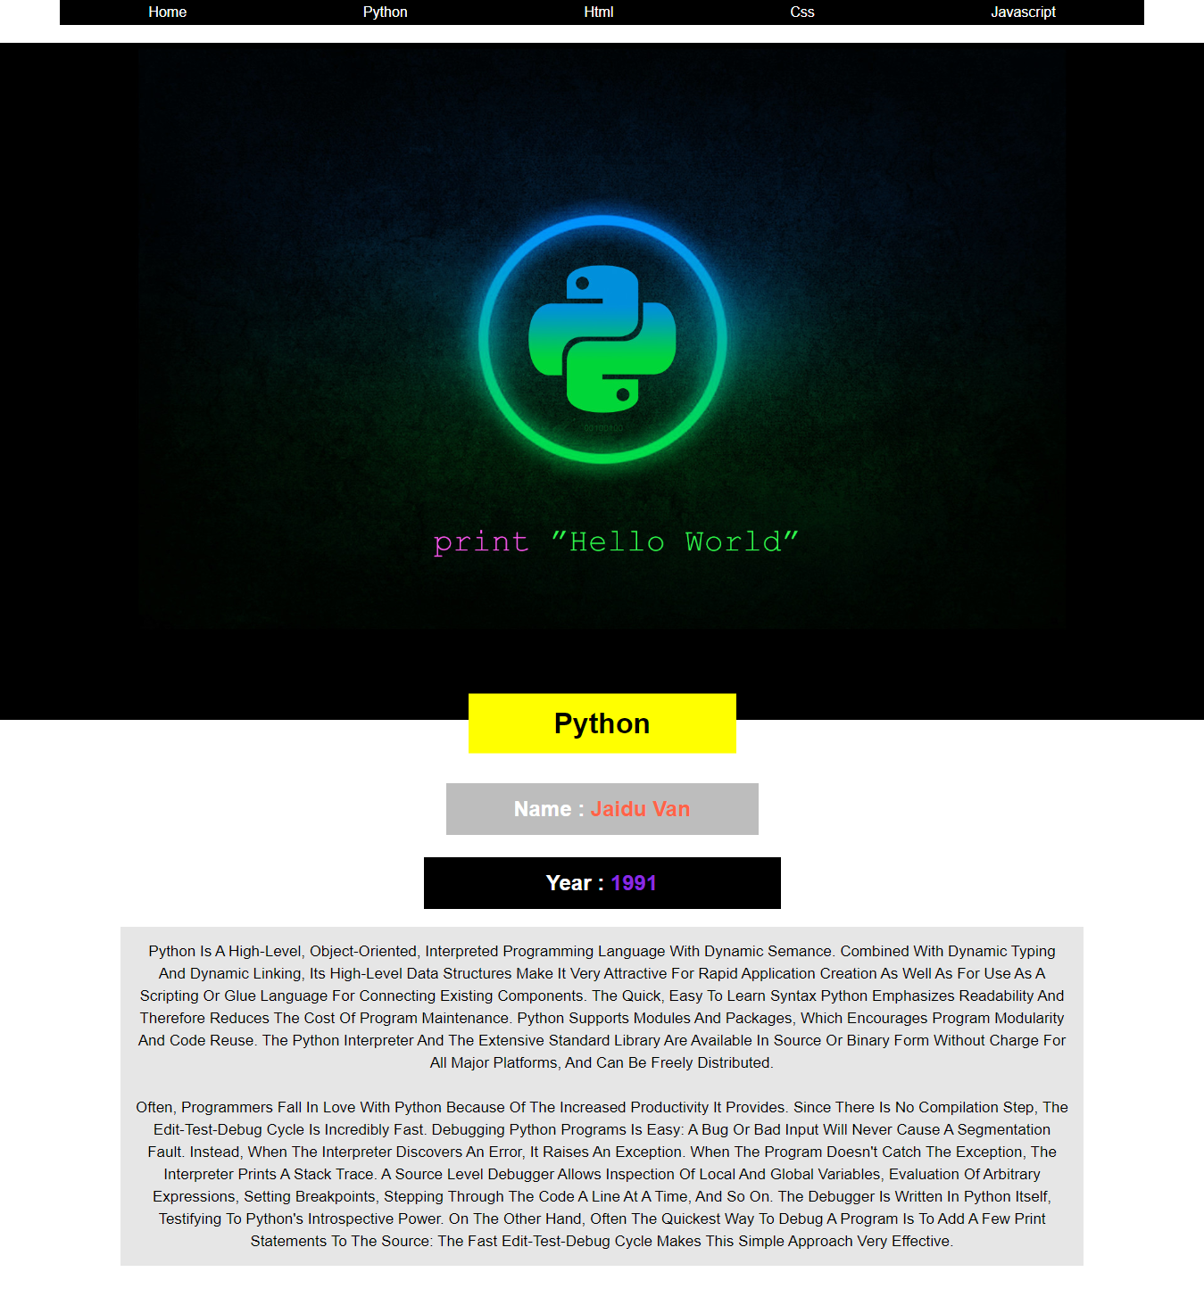

**Code screenshots:**

Html :

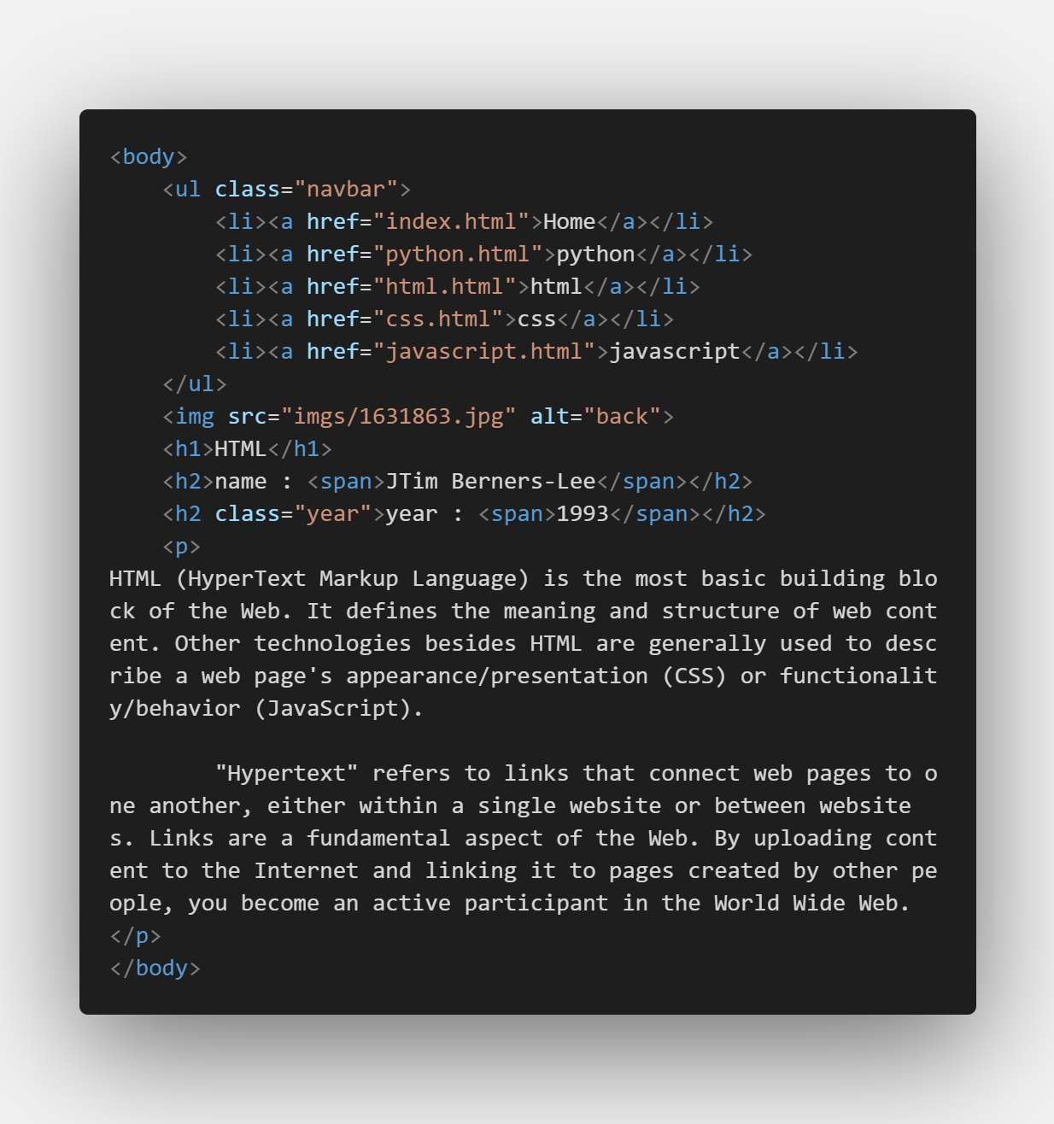

Style:

